*Take One* movie Theatre Ticketing System

Requirments document for information development system

Project Phase Two

Johané le Roux 31614744

Christopher Slaghuis 31713858

Jean Marx 32313845

Reinardt Nel 27327884

James Uys 28461789

Contents

**1.** **Project Plan** 2

**2.** **Definitions, acronyms and abbreviations** 3

**3.** **Project description and Scope** 4

**4.** **Functional requirements i.e.** 5

**a.** **business data requirements (inputs, outputs)** 5

**b.** **business processes requirements and** 5

**c.** **business interface requirements** 5

**5.** **Non-functional requirements (categorized according to the PIECES Framework)** 6

**6.** **Candidate Systems Matrix** 7

**7.** **Feasibility Analysis Matrix** 8

**8.** **Use-Case Glossary & Use-Case Model Diagram** 9

**9.** **Examples of data, questionnaires, fact-finding techniques used** 10

**10.** **Summary, future & further planning (PERT Chart)** 10

# **Project Plan**

# **Definitions, acronyms and abbreviations**

# **Project description and Scope**

The main objective of this project is to provide a computerized system for the BEAUT ART gallery to automate daily business processes and provide extensive business reporting to support business decisions. In addition the system should provide extensive Help functionality, backup functionality and data must be secured from unwanted access. Before the new system can be used in a production environment, all history data must be loaded from the existing Excel system. The FAST methodology, following several phases, will be used as a formal approach to develop and implement the system. The following functionality will be included in the scope of this project:

The *TAKE ONE movie theatre* is a new up and coming movie theatre in a residential area of South Africa. The movie theatre will show recently released **movies** as well as special movies for special occasions (e.g. Christmas season, Valentine’s day, ladies’ night). Audience members will be able to book **tickets** for the movie of their choice. Each day there will be a specific time schedule according to which the movies will be shown. **Members (loyalty program)** of the movie theatre will receive special deals and newsletters.

There is currently no *automated* system in place at the movie theatre, and the owners requested a system that is not run by a third party. However we will implement an Information System using existing hardware.

The system must include functionality for the following:

1. Maintain members of movie theatre
2. Maintain movies
   1. Regular movies that are newly released
   2. Special occasions (Valentines, ladies & boys nights, etc.)
3. Selling of tickets
   1. Notify client about ticket information when sale is complete.
   2. The notification will include their movie ticket code.
4. Indicate seats that are booked.
5. Export data
   1. Backups
   2. Profit margins
6. Request report:

* List of movies
* Attendance list of movies to determine popular genre per time period (e.g. comedy, drama, action)
* Audience size per time period (time of day, day of weekend)
* Graphical representation of popular times movies is watched.

# **Functional requirements i.e.**

## **business data requirements (inputs, outputs)**

## **business processes requirements and**

## **business interface requirements**

# **Non-functional requirements (categorized according to the PIECES Framework)**

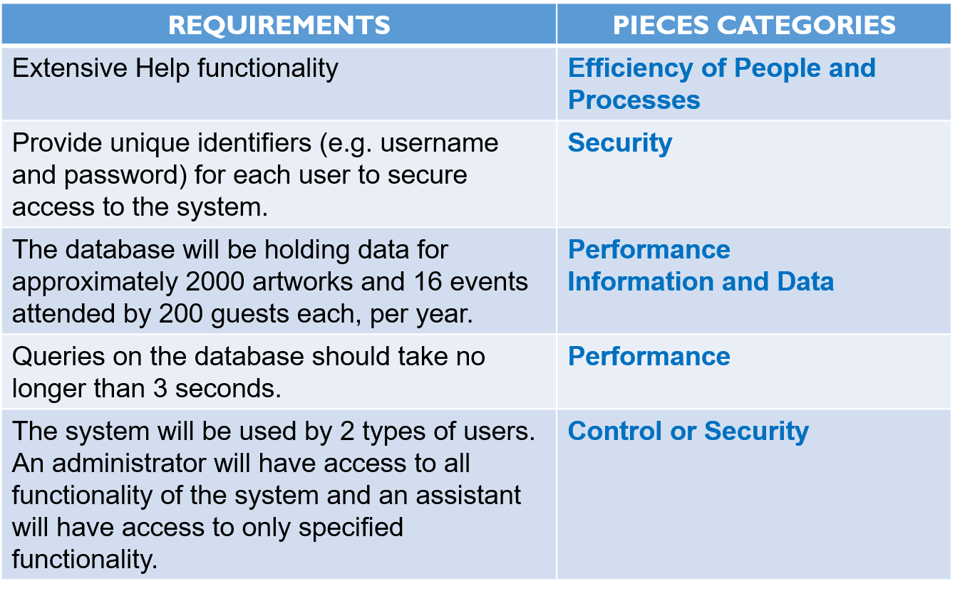

# **Candidate Systems Matrix**

# **Feasibility Analysis Matrix**

# **Use-Case Glossary & Use-Case Model Diagram**

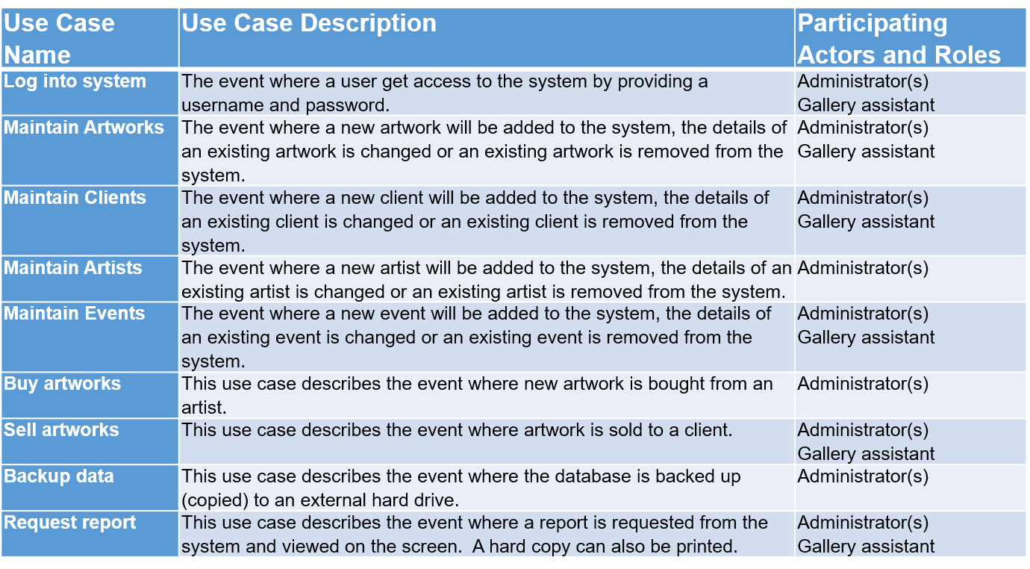

# **Examples of data, questionnaires, fact-finding techniques used**

# **Summary, future & further planning (PERT Chart)**